

YEAR: 7
2021
SUBJECT: Science

TEST: Classification
TIME: 45 minutes
QUESTIONS: 10 Multiple Choice (10 marks)
9 Short Answer (32 marks)
TOTAL MARKS: 42 marks

DO NOT WRITE ON OR MARK THIS PAPER

Part A: Multiple Choice Questions (10 marks)
Indicate Answer on Answer Sheet.

- Carl Linnaeus created a double naming system, which is used by scientists around the world today. Select from the options below how a scientific name is given to an organism.
- Species genus
- Species phylum
- Phylum species
- Genus species

- Select from the options below which organism would be the most closely related to the great hammerhead shark. The scientific name for the great hammerhead shark is Sphyrna mokarran.
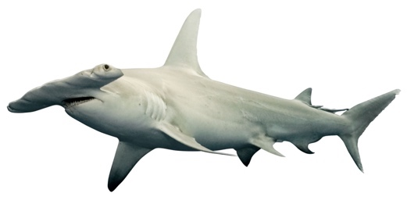
- Carcharodon carcharias
- Sphyrna lewini
- Carcharhinus mokarran
- Carcharhinus leucas

- Scientists classify organisms because:

  - it makes it easier to identify organisms.
  - there are only a few organisms that differ from each other.
  - most discoveries in biology have already been made.
  - all organisms have characteristics in common.

- Organisms can be grouped into five major kingdoms. These are:

  - mammals, fish, birds, amphibians and reptiles.
  - animalia, fungi, monera, plantae and protists.
  - animalia, fungi, insects, plantae and algae.
  - animalia, plantae, insects, birds and reptiles.

- The Linnaean system of classifying living things starts with large groups called:
- Phyla
- Species
- Classes
- Kingdoms

- Members of kingdom animalia:
- Are multicellular and gain energy from other living things.
- Are multicellular and can gain energy from other living things.
- Are unicellular and can gain energy from themselves.
- Are unicellular and can gain energy from other living things.

- The reason for using structural characteristics (rather than colour or size) for classification is:

  - structural features are easy to observe.
  - individuals of the same type can differ in colour.
  - organisms change size as they grow.
  - all of the above.

- The main difference between vertebrates and invertebrates is that:
- Vertebrates have a skeleton and invertebrates have an exoskeleton or no skeleton at all.
- Vertebrates have an external skeleton and invertebrates have an internal skeleton.
- Vertebrates are birds and invertebrates are fish.
- Vertebrates are fish and invertebrates are birds.

- Which kingdom does this creature belong to?
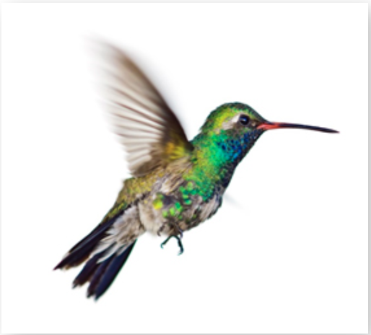
Top of Form
- Animalia
- Aves
- Protista
- Monera

- One of the features of the Plantae Kingdom is that all the organisms are autotrophs. Which of the following is the best definition for autotroph.

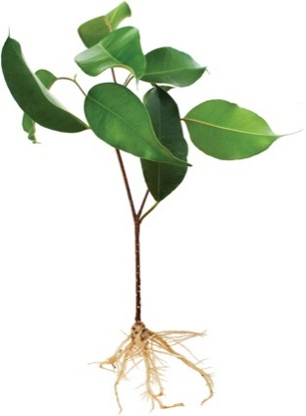
- A single celled organism.
- A multicellular organism.
- An organism that is able to produce its own food.
- An organism that is not able to produce its own food.



SEMESTER ONE 2021
Classification Science Test:
ANSWER BOOKLET

NAME:
FORM: DATE:

Multiple Choice Short Answer Total

/32

/10

/42

SECTION ONE: Multiple choice answers
Cross (X) through the correct answer.

1 | a | b | c | d
2 | a | b | c | d
3 | a | b | c | d
4 | a | b | c | d
5 | a | b | c | d
6 | a | b | c | d
7 | a | b | c | d
8 | a | b | c | d
9 | a | b | c | d
10 | a | b | c | d

ASSESSMENT KEY

I CAN STATEMENTS | QUESTIONS
MUST  Classifies organisms using observable similarities and differences and applying simple classification keys. | 3,4,5,6,7,8, 11, 12, 13, 14, 15, 17
SHOULD  Classifies organisms using observable similarities and differences, constructing and applying classification keys. | 1, 10, 11, 16, 17, 18, 20
COULD  Classifies unfamiliar organisms using observable similarities and differences, constructing and applying varied classification keys. | 2,9,17, 19

Part B: Short Answer Questions (32 marks)
Answer in the spaces provided.

11.Biologists use factors or criteria to determine whether something is living or non-living.
a) Using MR N GREWW, write down the 8 criteria that an object must satisfy to be considered living. (4 marks)

M
R
N
G
R
E
W
W

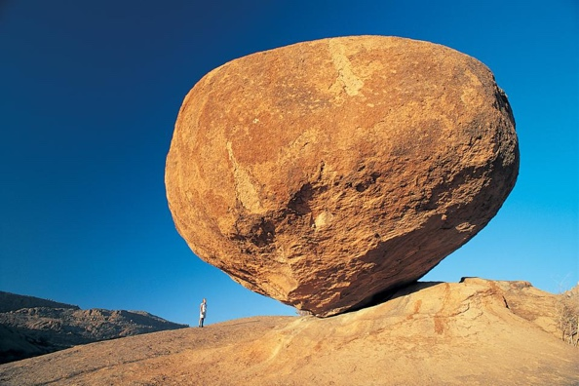
b) This is a picture of a rock.
Sammy thinks rocks are a living thing.
Bobby thinks the rocks are a non-living thing.
i) Who is correct? Bobby or Sammy? (1 mark)

ii) Using MR N GREWW, explain your answer. (2 marks)

12) Describe how to use a dichotomous key. (2 marks)

13) Do Aboriginal and Torres Strait Islander Peoples use the same or different classification system as Carl Linnaeus’ classification system. Explain your answer. (2 mark)

14)
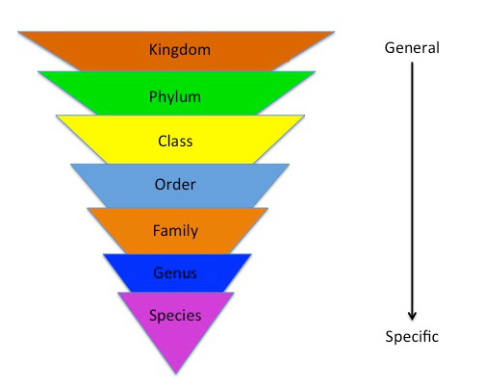
Identify the two missing groups from the Linnaeus classification system (1 mark)

15) Below is a branching classification key for invertebrates. Fill in the animals in the boxes of legs and no legs. Then use the key to fill in the table below it. (5 marks)

Please write the names of the animals in the boxes after the first question in the dichotomous key and then write the number you think the animal is in the table below.

Does the organism have antennae?
Does the organism have wings?
Wings
1

No Wings
2

Antennae
3

No Antennae
4

All animals: Worm, Bee, Slug, Spider
Question: Does the invertebrate have legs?

No Legs
Animals: ___________ ___________________
Legs
Animals: ___________ ___________________

Animal | Which box does this animal belong in? (put a number in each box from the key above)
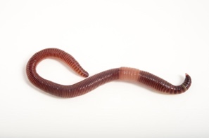

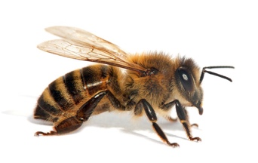

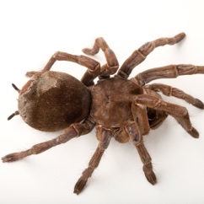
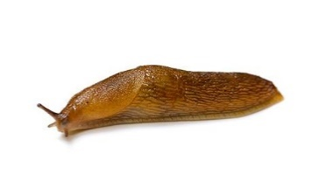

16) Tabular keys are also used for classification. Use the tabular key below to correctly identify the class of the following animals. (3 marks)

1 | Does the animal have feathers? | Feather’s present  Feathers not present | Aves  Go to 2
2 | Does the animal have fur or feathers? | Hair or fur present  No hair or fur | Mammalia  Go to 3
3 | Does the animal have fins? | Fin’s present  No fins present | Pisces  Go to 4
4 | Does the animal have scales? | Has moist skin, no scales  Has scales | Amphibian  Reptilia

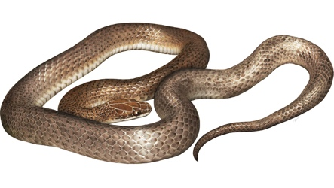 | 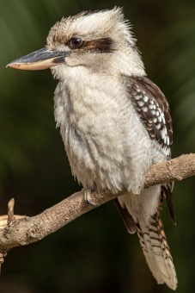 | 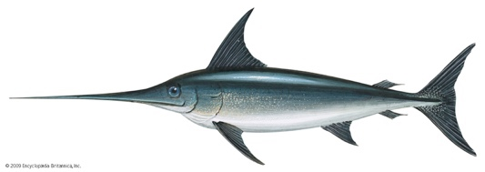
Class: | Class: | Class:
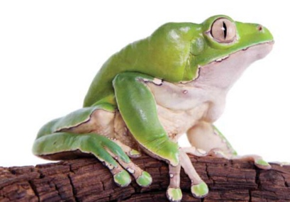 | 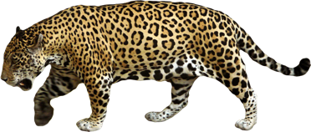 | 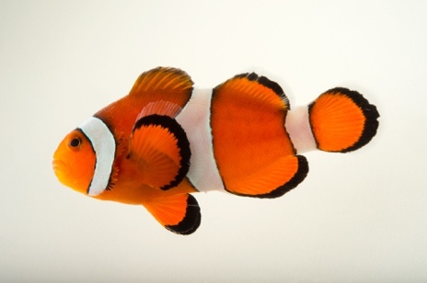
Class: | Class: | Class:

17) In the Kingdom Animalia organisms are identified by the type of skeleton present in the body. Complete the table below, identifying the type of skeleton of the animal and whether this classifies the organism as a vertebrate or invertebrate. (3 marks)

Organism | Endoskeleton/ exoskeleton/ no skeleton | Vertebrate or invertebrate
Octopus
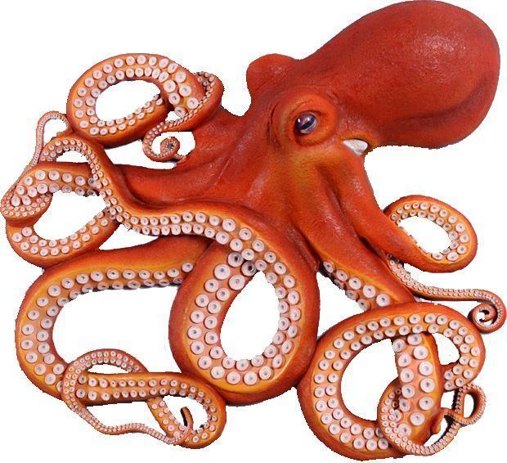

Prawn

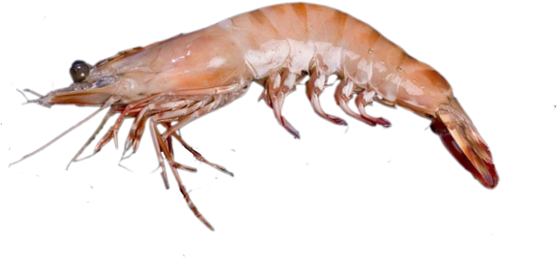

Fish
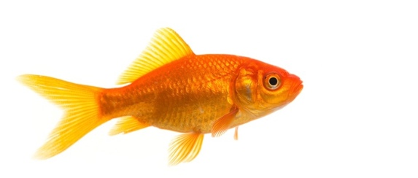

18) Henry has a group of animals (pictured below) he has been researching and wants to classify using a dichotomous key. Construct a classification key for Henry to use. The key has been started for you. (5 marks)

Half the dichotomous key has been completed for you. You must finish BOTH sides to gain full marks. (Hint: make sure you fill in the question and identify the animals).
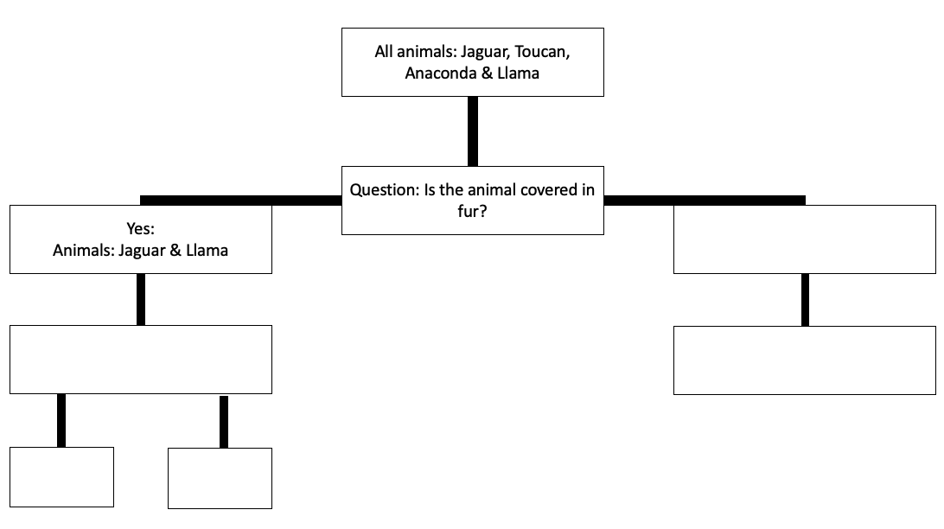
Jaguar | Toucan | Anaconda | Llama
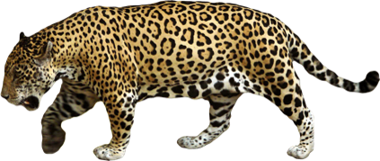 | 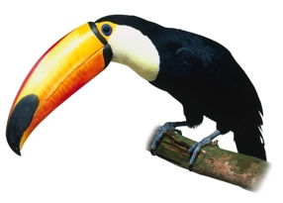 | 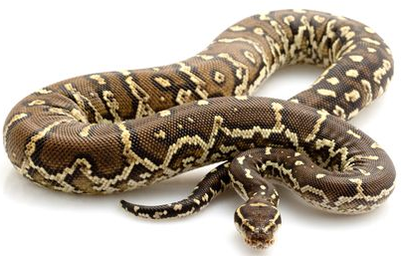 | 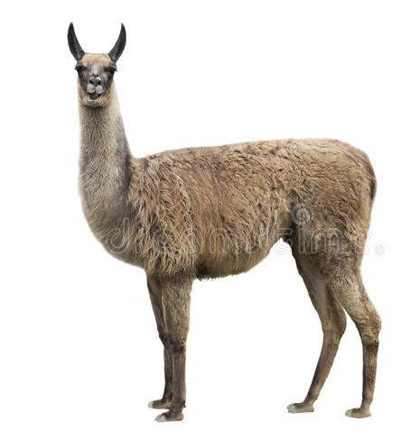

19) Describe the difference between an endoskeleton and an exoskeleton. (2 marks)

20) The Kingdoms are divided up by the arrangement of cells in an organism. (2 marks)

Using your knowledge of the common features of Kingdoms fill in the table below.

Kingdom | Unicellular or multicellular | Cell wall present?
Animalia
Plantae

END OF TEST

